24. FULL SUBTRACTOR

EXP.NO: 24

AIM: To design and implement the full subtractor using Logisim simulator.

PROCEDURE:

1)      Pick and place the necessary gates.

2)      Insert 3 inputs into the canvas.

3)      Connect the inputs to the XOR gate, AND gate and OR gate.

4)      Insert 2 outputs into the canvas.

5)      Make the connections using the connecting wires.

6)      Verify the truth table.

TRUTH TABLE:

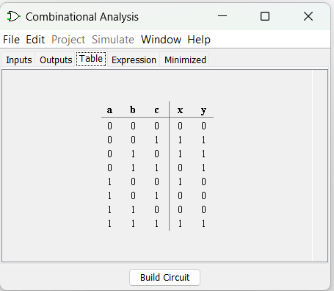

 Diff=(A ⊕ B) ⊕ &#39;Borrowin&#39;

Borrow=A&#39;.B + (A ⊕ B)&#39;

Logic Diagram:

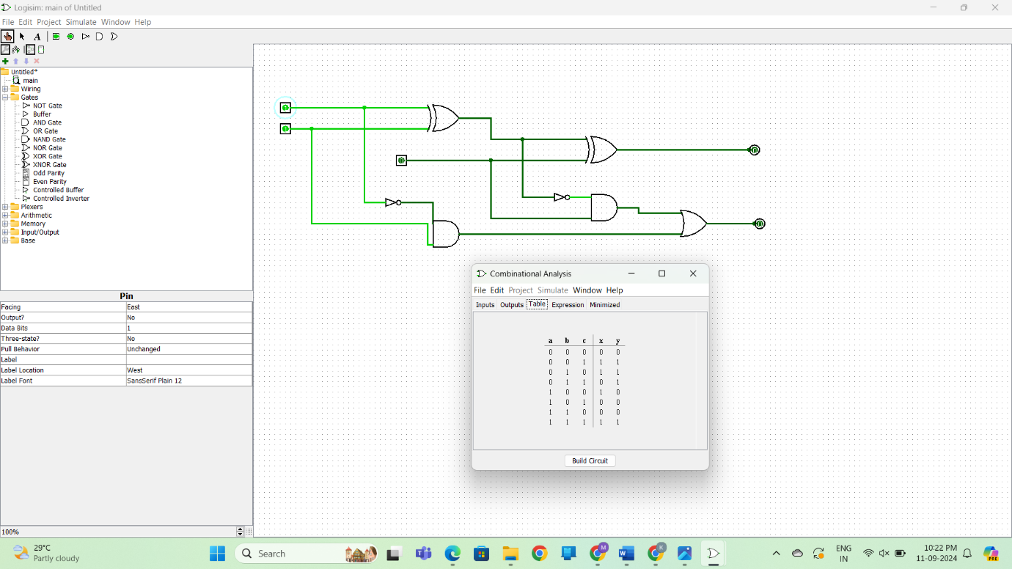

Full Subtractor using NAND Gates OUTPUT

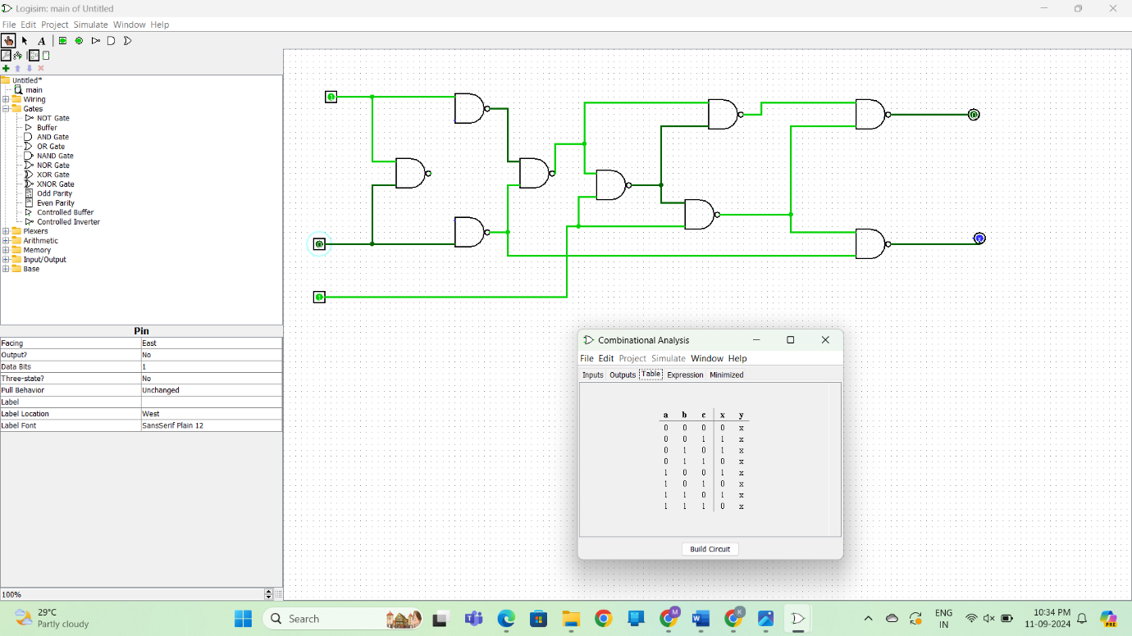

Full Subtractor using NOR Gates OUTPUT

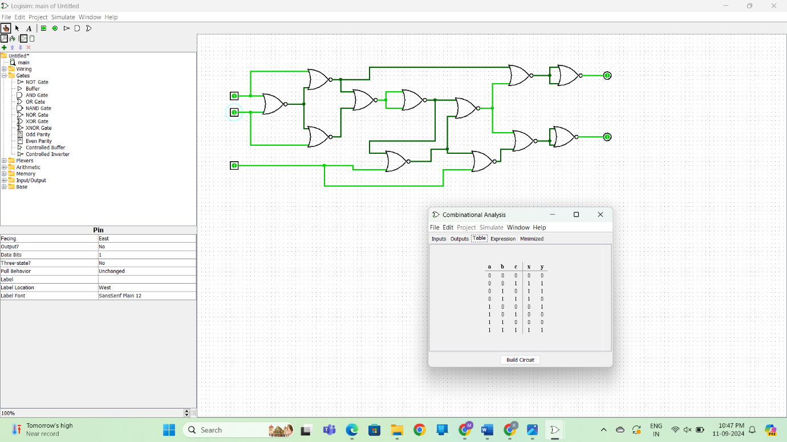

RESULT: Thus full subtractor has been designed and implemented successfully using

logisim simulator.